MARWA mohammed SAAR
Applied Machine & deep learning

Machine Learning (ML) is a field of Artificial Intelligence (AI) that allows computers to learn patterns from data and make predictions or decisions without being explicitly programmed.
Instead of writing rules, we give the machine data, and it learns patterns automatically.
Types of Machine Learning
1️⃣ Supervised Learning (Most common)
The model learns using labeled data (with correct answers).
Used for:
- Predicting numbers → Regression
- Predicting categories → Classification
Examples:
- Predicting house prices
- Predicting whether a customer will leave

2️⃣ Unsupervised Learning
The model finds patterns without labels (unlabeled data)
Used for:
- Grouping → Clustering
- Finding hidden patterns
- Anomaly detection
Examples:
- Customer segmentation

Traditional SDLC (Software Development Life Cycle) & Agile ML Workflow
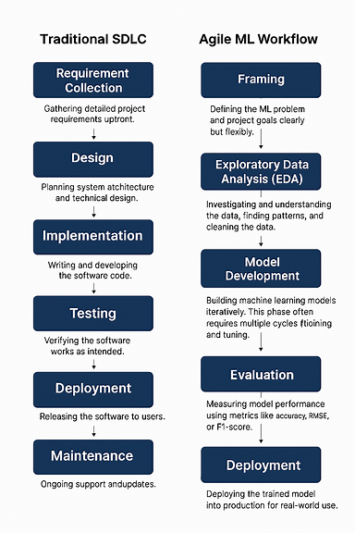
- Hyperparameters vs Parameters
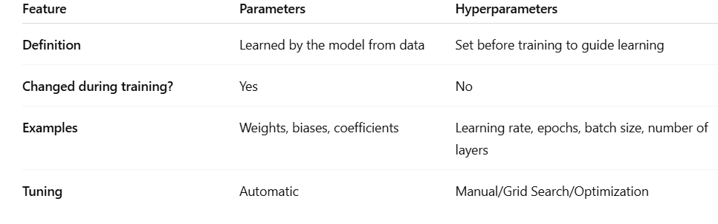
Hyperparameter Tuning Methods
- Grid Search: Tests all hyperparameter combinations; often combined with cross-validation. Exhaustive but computationally heavy.
- Random Search: Samples random combinations; faster, may miss the best set. Can use cross-validation for reliability.
- Cross-Validation Selection: Uses k-fold cross-validation to evaluate hyperparameters, improving generalization but adds computation.

- Machine Learning Workflow

1. Problem Definition
Clearly define what you are trying to predict or classify, the goal of the project, and how success will be measured.

2. Data Collection
Gather the data needed for the problem from sources like databases, APIs, sensors, web scraping, or datasets.

3. Data Cleaning
Prepare the data by fixing errors, removing duplicates, handling missing values, and dealing with outliers.

4. Exploratory Data Analysis (EDA)
Analyze the data using visualizations and statistics to understand patterns, distributions, relationships, and anomalies.

5. Feature Engineering
Transform raw data into meaningful inputs for the model (encoding, scaling, generating new features, text/vector extraction).

6. Feature Selection
Choose the most important features to reduce noise, improve training speed, and prevent overfitting.

7. Model Selection
Choose the best algorithm (e.g., Random Forest, SVM, Neural Network) based on the data type and problem.

8. Model Training
Fit the selected model to the training data so it can learn underlying patterns.

9. Model Evaluation
Evaluate model performance on validation/test data using metrics like accuracy, precision, recall, F1-score, RMSE, etc.

10. Hyperparameter Tuning
Optimize the model's settings using techniques like grid search, random search, or Bayesian optimization.

11. Deployment
Deploy the model to production so it can be used in real applications (APIs, mobile apps, cloud services).

12. Monitoring & Maintenance
Continuously track model performance, detect model drift, retrain with new data, and update features or parameters.

- GENERALIZATION IN MACHINE LEARNING
Generalization is an ML model’s ability to perform well on new, unseen data after being trained on a specific dataset.
A model that generalizes well has truly learned patterns, not memorized examples.

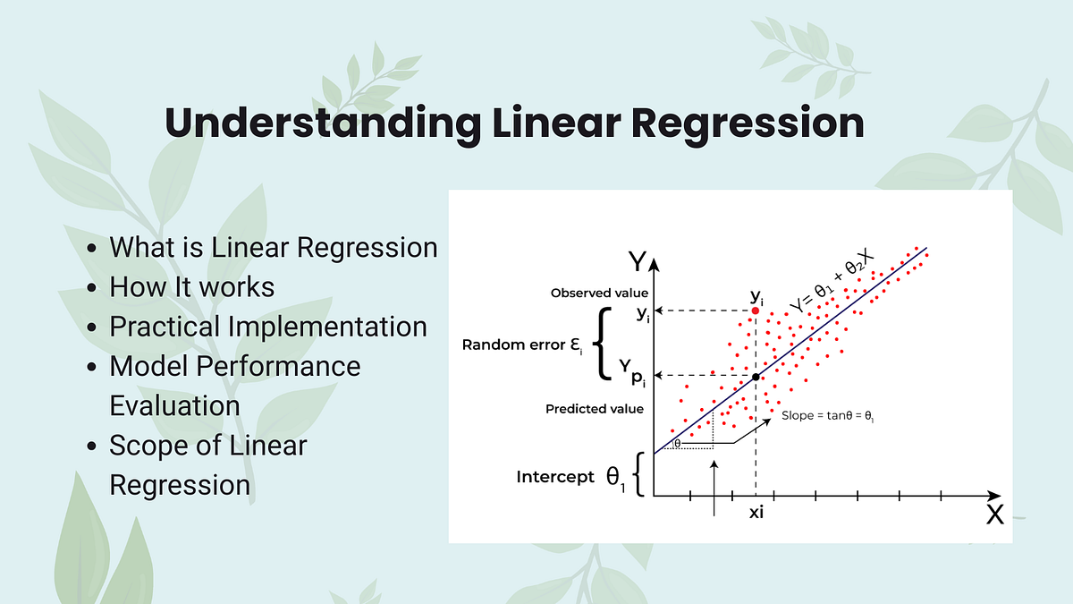

1. How Linear Regression Works
Linear regression predicts the value of a dependent variable $y$based on one or more independent variables $x$. It fits a line (or hyperplane) through the data that minimizes the difference between the actual values and the predicted values. The main idea is the least squares method, which minimizes the sum of squared errors.

2. Importance of Linear Regression
- Prediction: Estimates outcomes like sales, prices, or trends.
- Relationship Analysis: Understands how independent variables affect the dependent variable.
- Simplicity: Easy to implement and interpret.
- Basis for Advanced Models: Forms the foundation for many machine learning algorithms.

3. Mathematical Representation
Simple Linear Regression (one independent variable):
$$y=mx+b$$
- $m$= slope
- $b$= intercept
Multiple Linear Regression (multiple independent variables):
$$y=b_{0}+b_{1}x_{1}+b_{2}x_{2}+⋯+b_{n}x_{n}$$

4. Types of Linear Regression
- Simple Linear Regression: One independent variable.
- Multiple Linear Regression: Two or more independent variables.
- Polynomial Regression: Fits curves using powers of variables.
- Regularized Linear Regression:
  - Ridge Regression: Penalizes large coefficients.
  - Lasso Regression: Can shrink coefficients to zero.

5. Assumptions of Linear Regression
- Linearity: Relationship between independent and dependent variables is linear.
- Independence: Observations are independent of each other.
- Homoscedasticity: Constant variance of residuals.
- Normality: Residuals are normally distributed.
- No Multicollinearity: Independent variables are not highly correlated.

6. Best-Fit Line
The best-fit line minimizes the sum of squared vertical differences (errors) between predicted and actual $y$values.
Slope and Intercept Formulas:
$$m=\frac{n∑x_{i}y_{i}-∑x_{i}∑y_{i}}{n∑x_{i}^{2}-(∑x_{i})^{2}},b=\frac{∑y_{i}-m∑x_{i}}{n}$$

7. Cost Function
Linear regression uses the Mean Squared Error (MSE) as the cost function:
$$J(m,b)=\frac{1}{n}\sum_{i=1}^{n}{(}y_{i}-{\hat{y}}_{i})^{2}$$
Where ${\hat{y}}_{i}=mx_{i}+b$. Minimizing this function gives the best-fit line.

8. Model Evaluation
- R-squared ($R^{2}$): Proportion of variance explained by the model.
- Mean Squared Error (MSE): Average squared difference between predicted and actual values.
- Root Mean Squared Error (RMSE): Square root of MSE, in original units.
- Mean Absolute Error (MAE): Average absolute difference between predicted and actual values.
9-Scikit-learn Implementation
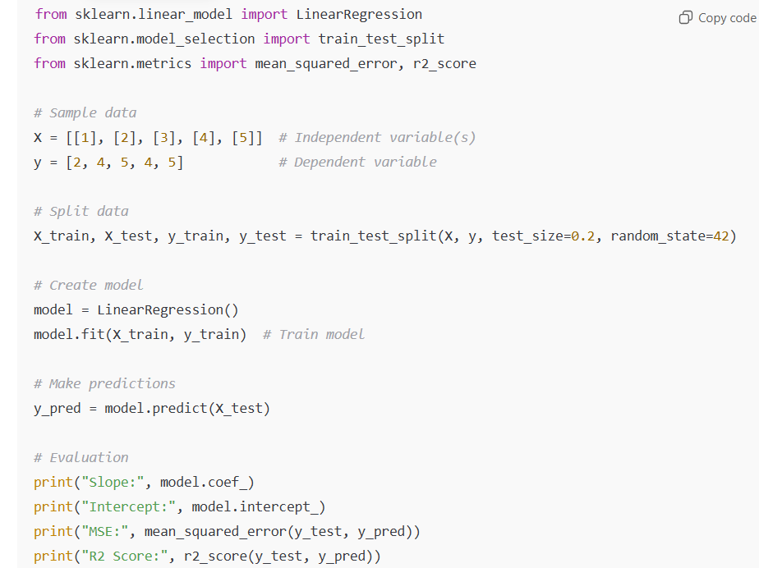

How Algorithms Learn
- See data → The algorithm observes the input features (data points) and the corresponding outputs (labels or target values). This is its “experience” from which it will learn patterns.
- Make predictions → Using its current parameters (like weights in a model), the algorithm predicts the outputs for the given inputs. Initially, predictions may be very inaccurate.
- Measure errors → The algorithm compares its predictions with the actual outputs and calculates a loss (or error) using a loss function. The loss quantifies how far off the predictions are from reality.
- Adjust parameters → The algorithm updates its parameters to reduce the loss. This step uses optimization techniques like gradient descent, which moves parameters in the direction that decreases the error.
- Repeat → This process continues iteratively: predict → measure → adjust. With each cycle, the model improves, gradually learning the patterns in the data.
- Evaluate and generalize → After learning, the algorithm is tested on new, unseen data. A well-learned model generalizes patterns rather than just memorizing the training data, allowing it to make accurate predictions on real-world inputs.

Residual
A residual is the difference between the actual value and the predicted value of a data point in a regression model.
$$\text{Residual}=\text{Actual value}-\text{Predicted value}$$Why Residuals Matter
- Measure Accuracy: Residuals show how well the model fits the data. Smaller residuals → better fit.
- Assumption Checking: In linear regression, we assume residuals are randomly distributed with constant variance (homoscedasticity) and are normally distributed.
- Detect Outliers: Large residuals indicate data points that the model predicts poorly.

Epoch
An epoch is one complete pass through the entire training dataset by the learning algorithm.
- If your training set has 1,000 examples, one epoch means the model has seen all 1,000 examples once.
- In practice, models often require multiple epochs to learn effectively.

